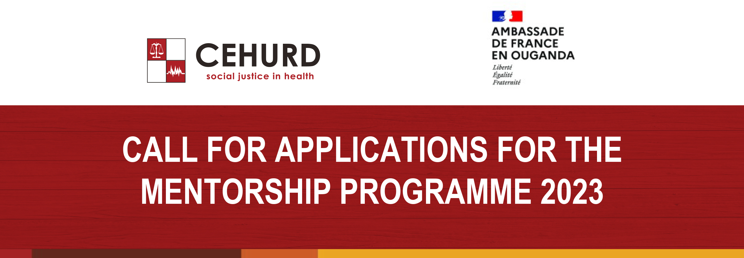
Questionnaire: Mentee Intake Form
Introduction
Feminist mentorship is a pathway to sustaining, developing and grooming feminist leadership at individual and organizational level. By extension, feminist mentorship is a strategy for sustaining feminist organizing and movement building. Challenging patriarchy and other power structures is a daily political endeavor that takes a toll on feminist activists – at personal and collective level. Feminist mentorship is a necessary tool in our armor as feminists where we can create safe spaces for intergenerational and peer support, for learning new theories and tools, for unlearning values and norms that do not serve us, for encouraging sisterhood and collaboration, for growing our constituency, and for holding each other and our organizations accountable as we challenge oppression both within our social movements as much as external to our movements.
We believe that feminist mentoring will create a safe space where mentors and mentees share feminist ideology, values and vision by walking the journey together.

No. | Information required | Your response
1. | Name:
2. | Date of Birth:
3. | Affiliated Organization:
4. | Organizations focus areas of work:
4. | Feminist concepts
4. | Advocacy
4. | Public Speaking
4. | Climate change/eco-systems
4. | SRHR and bodily autonomy
5. | Contact Number:
6. | Email Address:
7. | Highest Level of Education Attained:
8. | Nationality:
9. | Residence / District:

- What is your understanding of feminism? (100 words max)

- Why are you interested in participating in a feminist mentorship programme? (150 words max)

- What do you want to achieve from the mentorship program? (100 words)

- Which of the following areas would be most important to you to focus on during your mentorship journey? (Tick in 2 preferred boxes)

- Feminist concepts- Feminism involves the belief in full social, economic, and political equality for women.
- Advocacy- This involves getting support from another person to help you express your views and wishes, and help you stand up for your rights.
- Public Speaking - This involves the process of communicating information to a live audience. The type of information communicated is deliberately structured to inform, persuade, and entertain.
- Climate change/eco-systems- Climate change is a long-term change in the average weather patterns that have come to define Earth's local, regional and global climates.
- SRHR and bodily autonomy- SRHR is more than just reproductive health. This involves access to information to make right decisions, choice, consent, bodily autonomy and integrity, sexuality education (SE), and so much more are part of what makes up SRHR.
- Gender based violence- involves harmful acts directed at an individual based on their gender.

- How much experience do you have working in any of the above areas?

- We envision an intergenerational learning exchange between mentees who will mostly be from Generation Z, and mentors from Generation X or Millennial. How are you, as a potential mentee, able to enrich the knowledge and skills of a mentor who is from a different generation than you? (150 words)

- If you were selected to participate in the mentorship programme, how much time would you be willing to dedicate to this process on a weekly basis? (Tick in your preferred box)

- Less than 2 hours

- 2-5 hours

- 5-10 hours

- More than 10 hours

